**Integrate Katalon with TeamCity**

Assume that we have two machines: machine A for scripting and machine B for executing. On machine B we can use machine B to execute test suite either through TeamCity agent or trigger execution immediately if you want.

1. **Preparations:**
   1. **Prepare Katalon and test project**

* On machine A, open Katalon and create a Katalon test project, then import it to your desired repository

Imported folder and file .prj should have the same name. Later, when we modify test project, we should NOT commit those folders and files to SVN: **bin, Libs, Reports**

* On machine B, prepare location to store Katalon build and test project. Install TeamCity
  1. **Configure TeamCity :**

Login TeamCity > Create new project

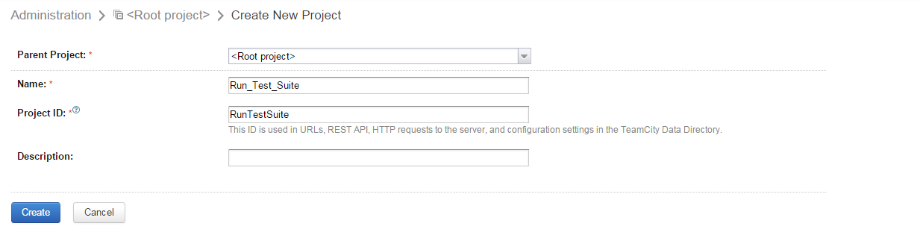

Create new build configuration to retrieve project sources from machine A

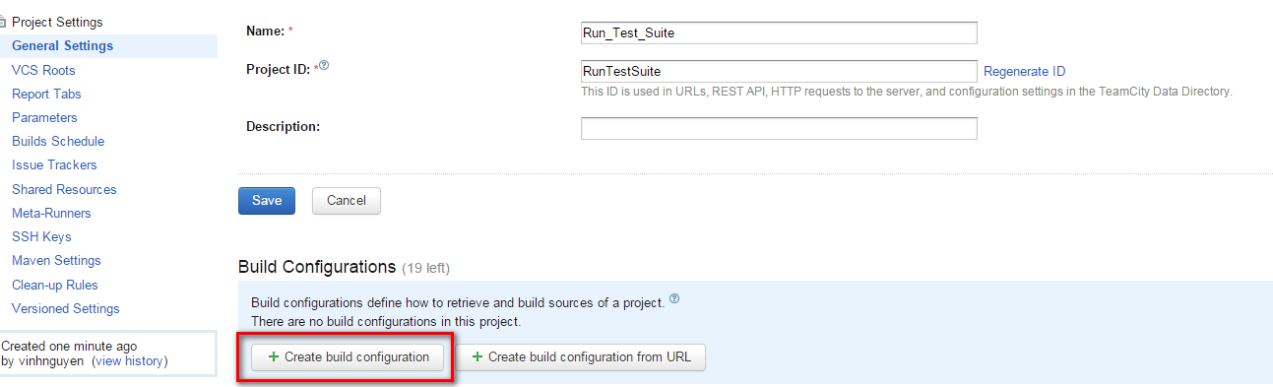

Input desired name and other information for new build configuration

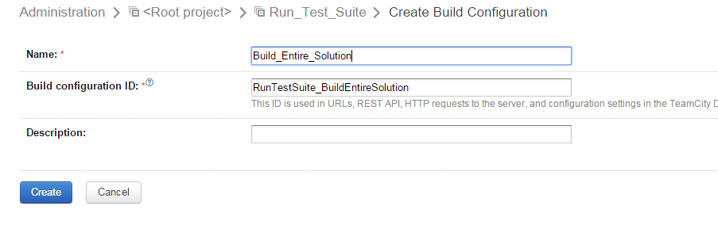

Finish above step will redirect you to “New VCS Root” page. On “New VCS Root” form: specify SVN repository that hold project sources along with other required information. Submit the form to let TeamCity create your desired new VCS root

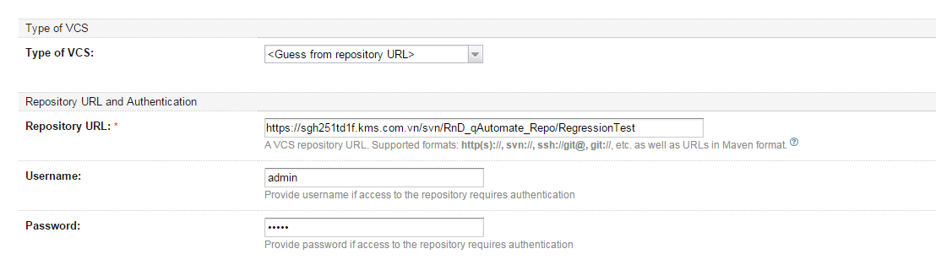

Open project configuration settings page, click on “Edit” link of recently created build to attach VCS root and edit other information if necessary

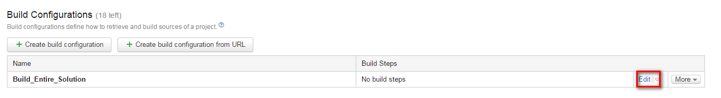

Open “Version Control Settings” page , click on “Attach VCS root” to attach recently created VCS root. If you haven’t created VCS root yet, it will display “Create new VCS root” for you.

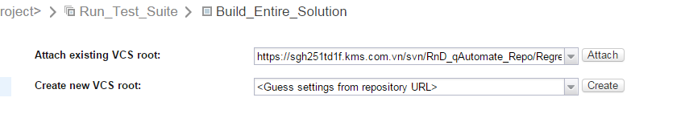

1. **Define build steps:**

Open “Build Steps” page to define necessary steps for executing project that we’ve already checked out in machine B

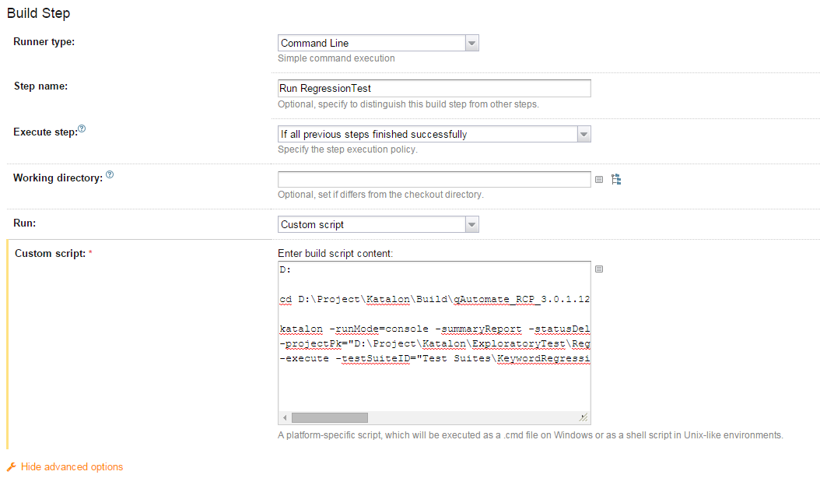

For the above command lines:

* First two lines are used to navigate to Katalon build folder
* Third line will be execution command line to run specified test suite. This is a sample of it:

katalon -runMode=console -summaryReport -statusDelay=30 ^

-projectPk="D:\Project\Katalon\ExploratoryTest\RegressionTest.prj" ^

-execute -testSuiteID="Test Suites\KeywordRegression\TS_AlertClassKeywordRegression" -browserType=Chrome -reportFolder="Reports\KeywordRegression\TS_AlertClassKeywordRegression\ChromeRun"

**3. Verify setup and monitor process:**

After you have done all of steps above, you can execute your test suite on TeamCity under machine B for verification.

Open build configuration settings page, click on “Run” button to start building and executing test suite using console mode:

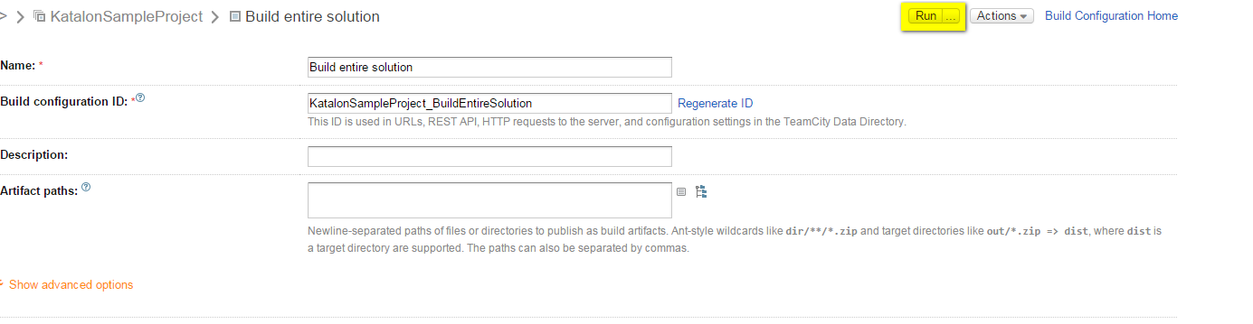

Navigate to project details page to see your selected job process:

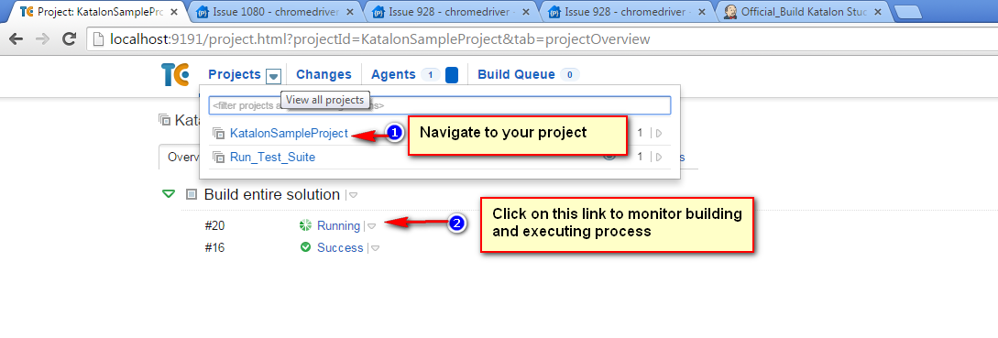

Click on “Build Log” tab to verify whether project sources are updated and console mode is run successfully

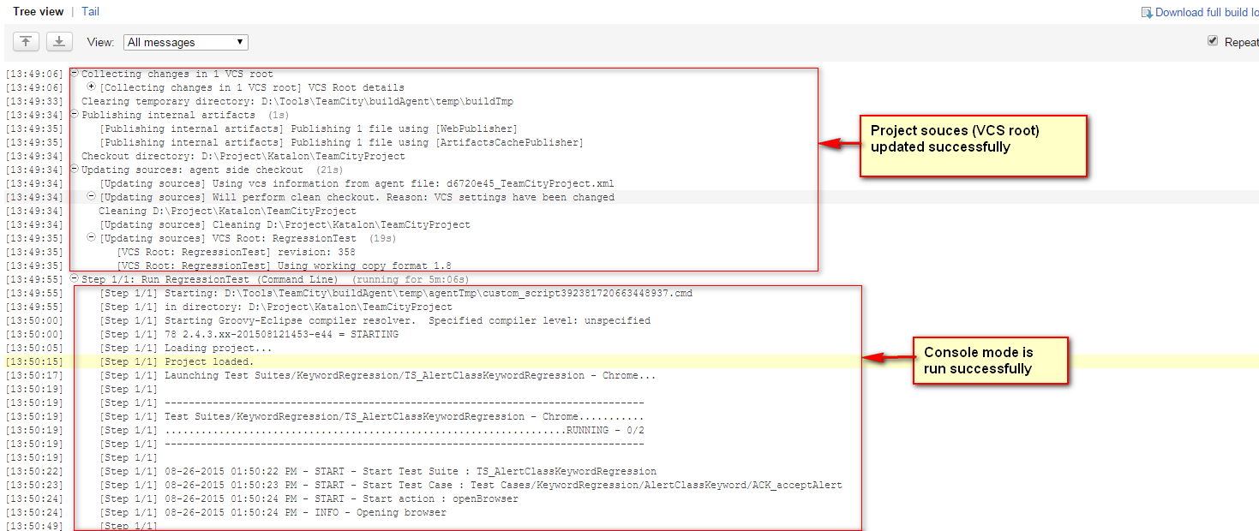

***In case you want to make machine B run console mode immediately after scripts on machine A have been committed, you can do the following:***

* On “Edit configuration build settings” page, click on “Trigger” link to open trigger configurations page. Click on “Add new Trigger” button to add a new trigger
* Select “VCS” trigger from the list, and then check on “Trigger a build on each check-in” and “Include several check-ins in a build if they are from the same committer” checkboxes.

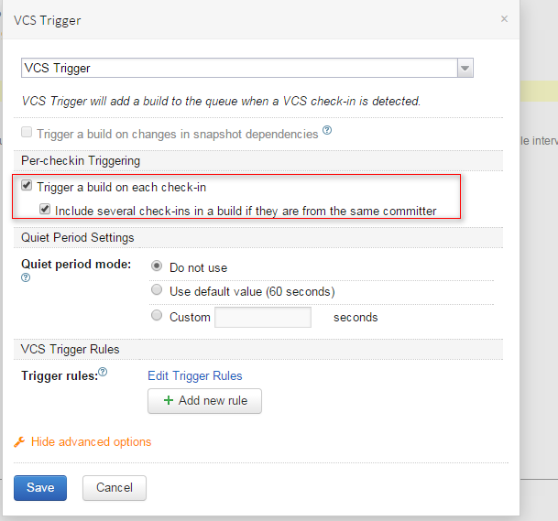

* Click “Save” button to create above trigger



Now everytime machine A make changes to project sources by committing scripts to repository, then machine B will automatically update them and run selected test suite through console mode

***In case you want to make machine B as an agent and will run selected test suite that you want, you can do the following.***

* On machine B: install TeamCity agent using this guide:

<https://confluence.jetbrains.com/display/TCD8/Setting+up+and+Running+Additional+Build+Agents>

* After you’ve setup machine B to be an agent successfully, you will see a new agent item available in the list of connected agent of machine A

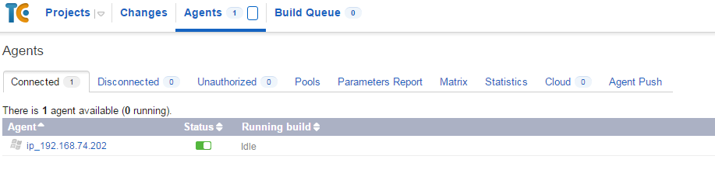

* On machine A: open “Build configuration settings” to specify machine B as an agent to run your selected test suite

Open “Agent Requirements” page, click on “Add new requirement” button and add the following cofigurations

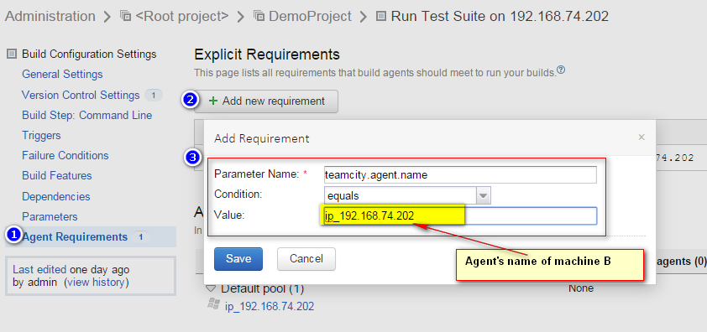

It’s done, now everytime you run your test suite using Katalon command line, the execution will happen on machine B

**Increase maximum heap size:**

You will need to increase maximum heap size for both Katalon and TeamCity in case you want to run hundred of test cases at the same time.

1. **Katalon:**

Open **katalon.ini** file and modify –Xmx value to be the size that you want. The default value is 512m, and the suggested value for running hundred of test cases should be 1024m or bigger.

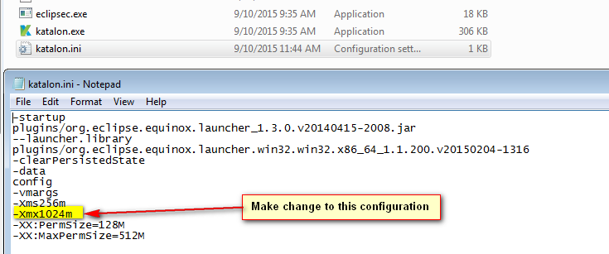

1. **TeamCity:**

In your current OS, open “Environment Variables” settings and add this new “system variable”

-Variable name: TEAMCITY_SERVER_MEM_OPTS

-Variable value: -Xmx1024m -XX:MaxPermSize=512m

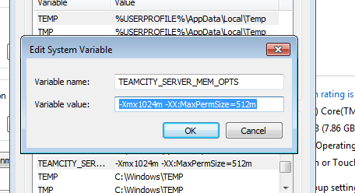

Reboot your machine to let this new value take effect